3. Hardware

The primary goal of the mechanical sub-team was to build and maintain a safe, durable, reliable platform on which the electrical and software could successfully execute their tasks. The frame sits upon a steering system comprised of two rear drive wheels and a caster situated in the front. The chassis contains two cases for the storage of electrical components, and also includes a rear mast for mounting sensors and housing external interfaces. Moxom’s Master incorporates many components of previous years’ designs, but several elements have been improved, with the primary goal of improving the robot’s mobility. Our approach to the improvement of our design was inspired by the product development process outlined by Ulrich and Eppinger in *Product Design and Development* which ensures a structured and consistent process. Conceptual designs and redesigns are engendered through the process of brainstorming and evaluated with considerations to the criteria of safety, cost , ease of construction, and sturdiness, as well as the needs of the other sub-teams.

3.1 Durability

There have been substantial improvements upon the previous design in regards to durability and reduction in the risk of mechanical failure. To protect against corrosion, all steel parts are now stainless or painted. Three main sources of mechanical failure were revealed during testing and operation. The first source observed was the loosening of bolts in the drive train assembly. To reduce the potential of bolts slipping loose, lock washers and Locktite are now used to secure all bolts in the drive train assembly. Secondly, the chains connecting the encoders to the drive wheels would commonly come dislodge. This issue was lessened by the installation of adjustable encoder mounts. The third source of mechanical failure was the shearing in the wheel hubs due the substantial weight of the robot. Mechanical failure actually occurred for this reason; a more detailed explanation and the team’s solution are presented below.

3.2 Stability

The robot originally had a 4 wheel skid steer drive.  While this was an extremely stable setup, it was also unnecessarily heavy and restricted mobility, and caused the high center of gravity caused the robot to lurch upon stopping. This year, the robot’s design was modified to be a compromise between the two.  Replacing the 2 front wheels with a single caster wheel decreased the weight of the robot by about 30 lbs., with minimal losses to stability. By replacing the mast with lighter aluminum, the team reduced weight by an additional 15 and moved the robot’s center of gravity lower to the ground. To decrease vibration for electrical components, the robot remains on a suspension system which is formed by 2 springs mounted between the wheels and the chassis.  Additionally, the choice was made to use a pneumatic castor, which would absorb some of the forward jolts.

3.3 Modularity

Moxom’s Master is designed to be modular to allow for easy installation of new parts and the ability to modify the robot with minimal downtime. The team used T-slot T-slot aluminum for the main frame of the robot because of the easy to use prefabricated tabs and brackets for mounting. We elected to use bolted angle aluminum for the rear mast as a weight-saving measure, minimizing the weight necessary to support the few components in the mast while allowing the possibility of installing new components, should the need arise. All of the plastic panels are easily removable to provide quick access to the robot’s internal components. Our computer and many of the other electronic components are mounted in sliding server drawers that can be removed from the robot for replacement or repair. Our mast holds the rest of the electronics, including a fold-out keyboard and screen for troubleshooting and robot feedback, as well as the GPS, LIDAR, and video camera.

3.4 Improvements

The team originally chose tractor tires and wheels because they were inexpensive and readily available. After several months of use, one hub failed catastrophically, and two other hubs had deformed to the point of breaking their paint and neared failure. The team already had spare wheel hubs available and wanted to use these to replace the broken hubs. A solution was sought to prevent a similar failure on the replacement wheels.

The proposed redesign involves welding an additional doughnut-shaped plate to the hub. This effectively makes the portion of the hub structure that is under the greatest stress three times thicker. Additionally, the weld provides a fillet with a greater radius than the existing design, reducing the stress concentrations at the joint where failure occurred.

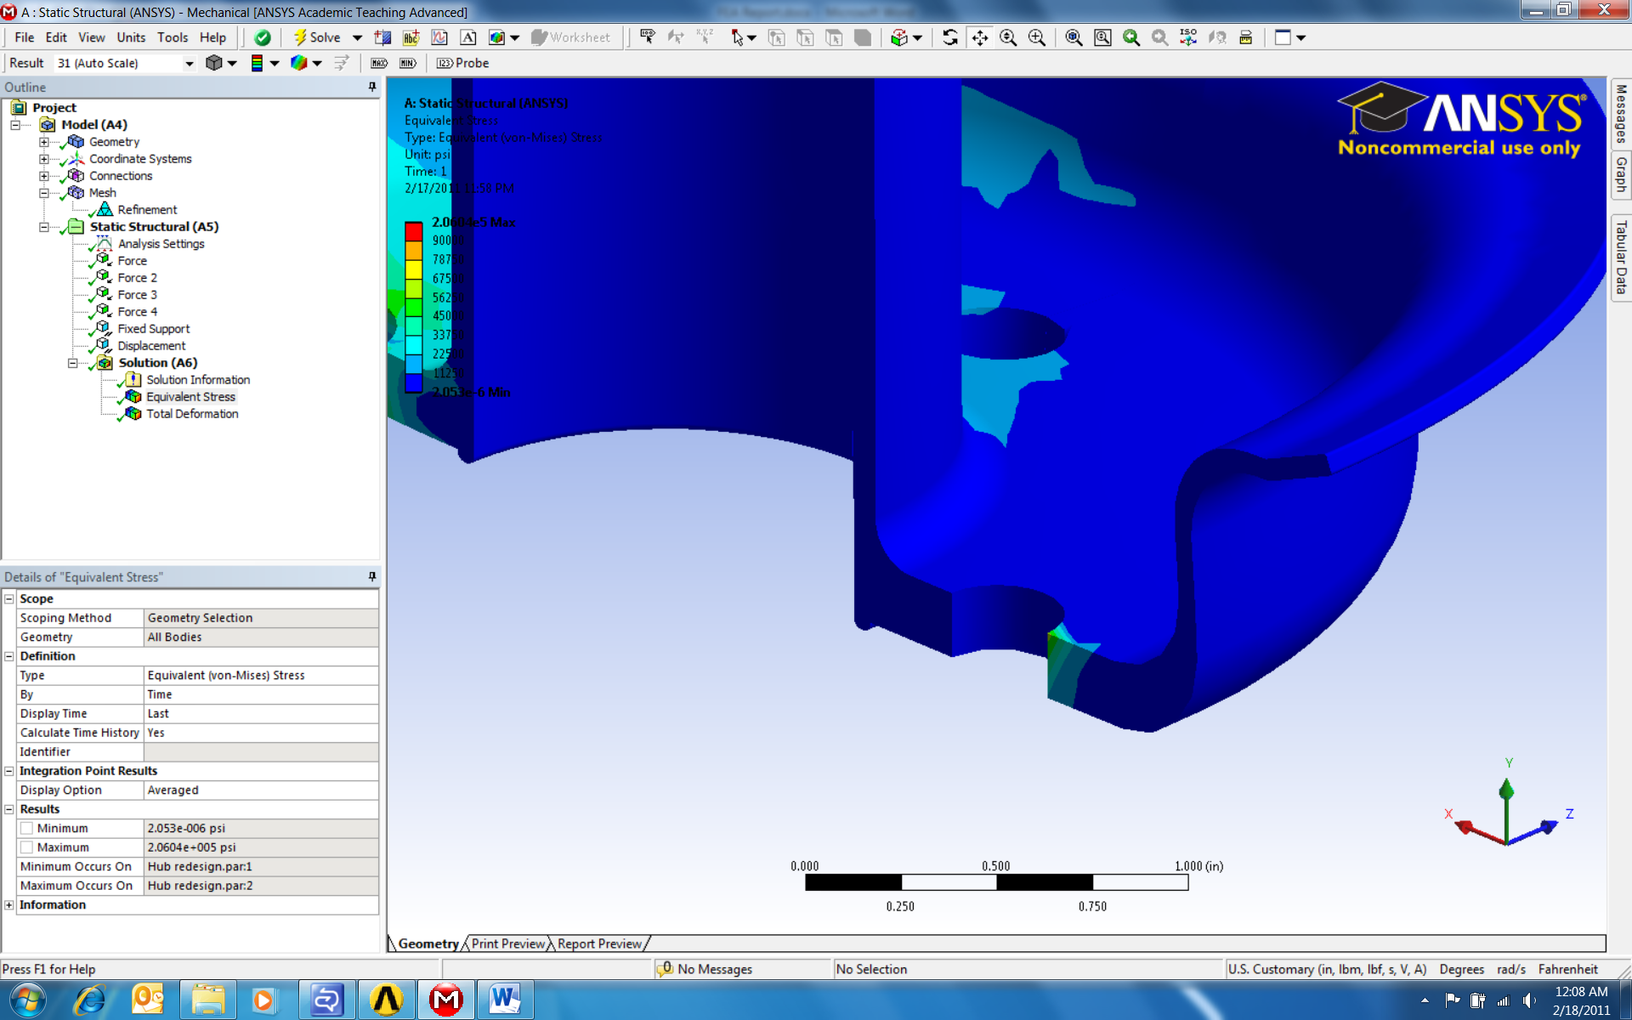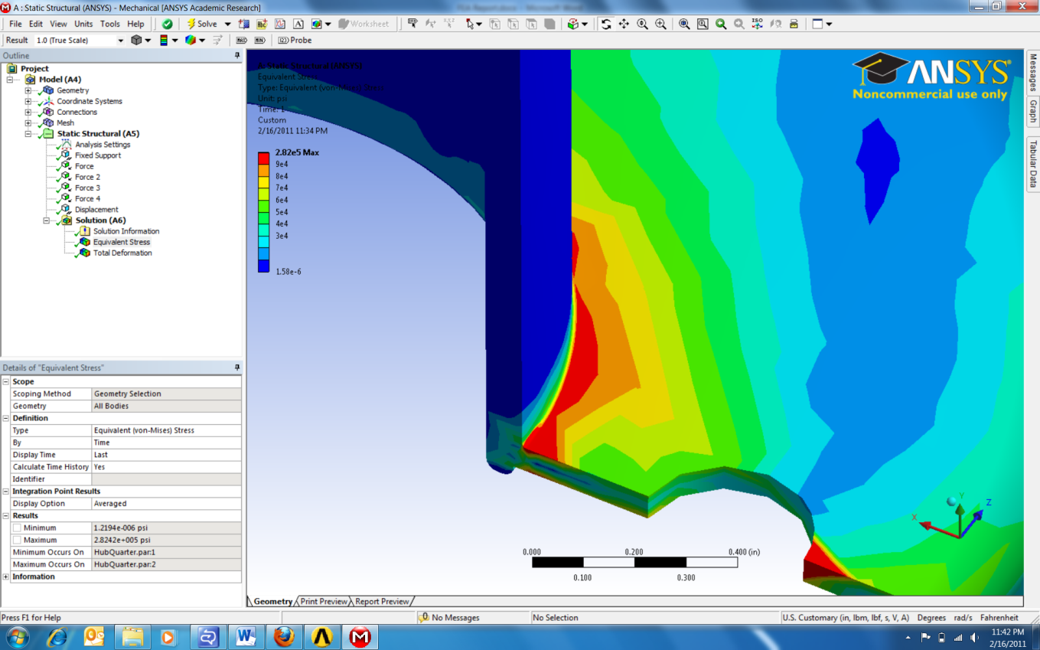

Figure 3.1: Stresses at joint for original hub (left) and redesign (right)

As shown in Figure 3.1, analysis reveals a reveal a large stress concentration around the center of the hub where failure occurred on the actual part. Red indicates an area of expected failure, with a maximum equivalent stress at the joint of 116,000 psi. Next, the analysis was repeated for the redesigned hub. As can be seen in Figure 3.2, the stresses around the hub are greatly reduced. The maximum stress on the redesigned hub is 32,000 psi, which results in a safety factor of 2.8.

As mentioned previously, a new castor was installed to replace the front two drive wheels. Doing so resulted in significant gains in maneuverability, due to the elimination of skid steering. The switch in steering type also reduced stress in the hubs, removing the outward friction force caused by turning, an inherent aspect of skid steering. Losses in speed due to the loss of the forward drive motors were negligible, as the elimination of a large amount of weight from the front (the forward drivetrain and top server case, see below) shifted the robot’s center of gravity rearward. This caused greater normal force against the rear wheels, allowing the drive motors to operate more effectively.

Additionally, significant steps were taken to reduce the weight of the robot. As the rear sensor mast’s size was defined by the by the location of the sensors, rather than high loads, it was an ideal place to start. The T-slot uprights used were excessive, given the minimal weight of the electronic components in the mast. Thus, the robot’s mast was rebuilt; using lighter aluminum angle instead of T-slot, the robot shed just over 15 lbs. with no reduction in functionality. The removal of the front drive wheels, motors, gearboxes, suspension, and mountings, for reasons listed above, further reduced the weight of the robot by 30 lbs. Finally, the decision was made to remove the top server case from the robot, which contained the battery charger. Doing so necessitated a new, portable case for transporting the charger, but lightened the robot by 35 lbs. The cumulative result of these reductions is the dramatic increase in robot’s acceleration, max speed, and turn speed, with no negative impacts to electrical or sensor on-field functionality.